Radioactive Dating Game Instructions

1. Open the following website:
https://archive.cnx.org/specials/d709a8b0-068c-11e6-bcfb-f38266817c66/radioactive-dating-game/#sim-dating-game

2. Make sure that the tab “Dating Game” is clicked at the top of the page. The page will look something like this:

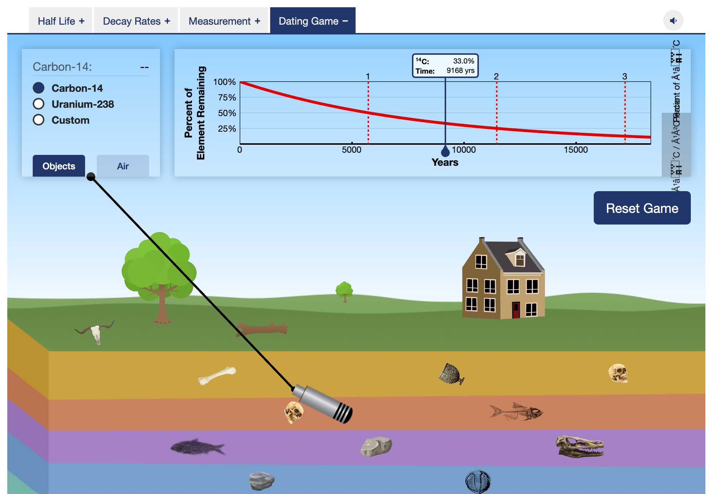

3. The little microphone with the cord is actually the dating tool you will be using. Each item has a name associated with it that will pop up when you move that dating tool over it:

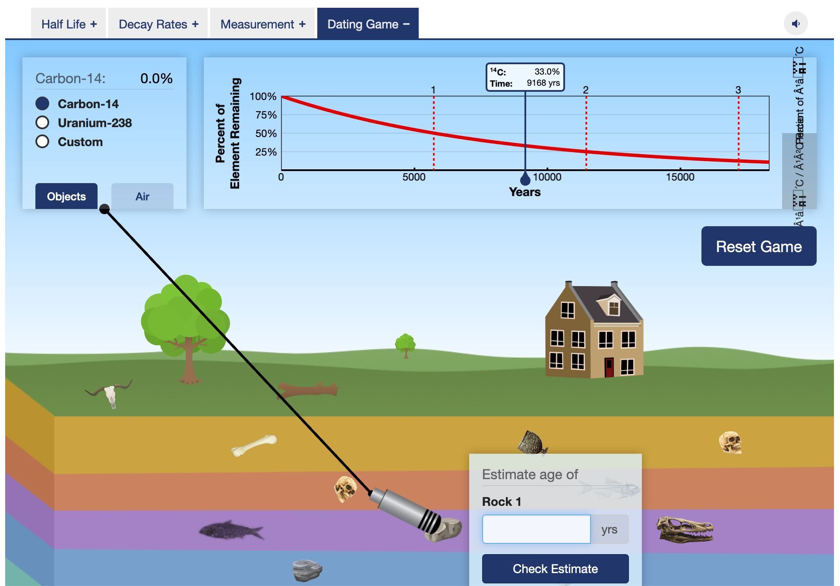

4. Notice how when I move the dating tool to “Rock 1”, information pops up in the chart at the top of the page. In this case, it reads ¹⁴C: 33%. This is because the radio button is clicked next to Carbon-14 in the upper left corner of the screen. We really don’t date rocks using Carbon-14 (only animal bones and plant material). We use Uranium-238 to date old, old things -- like rocks! So, let’s click on the Uranium-238 button:

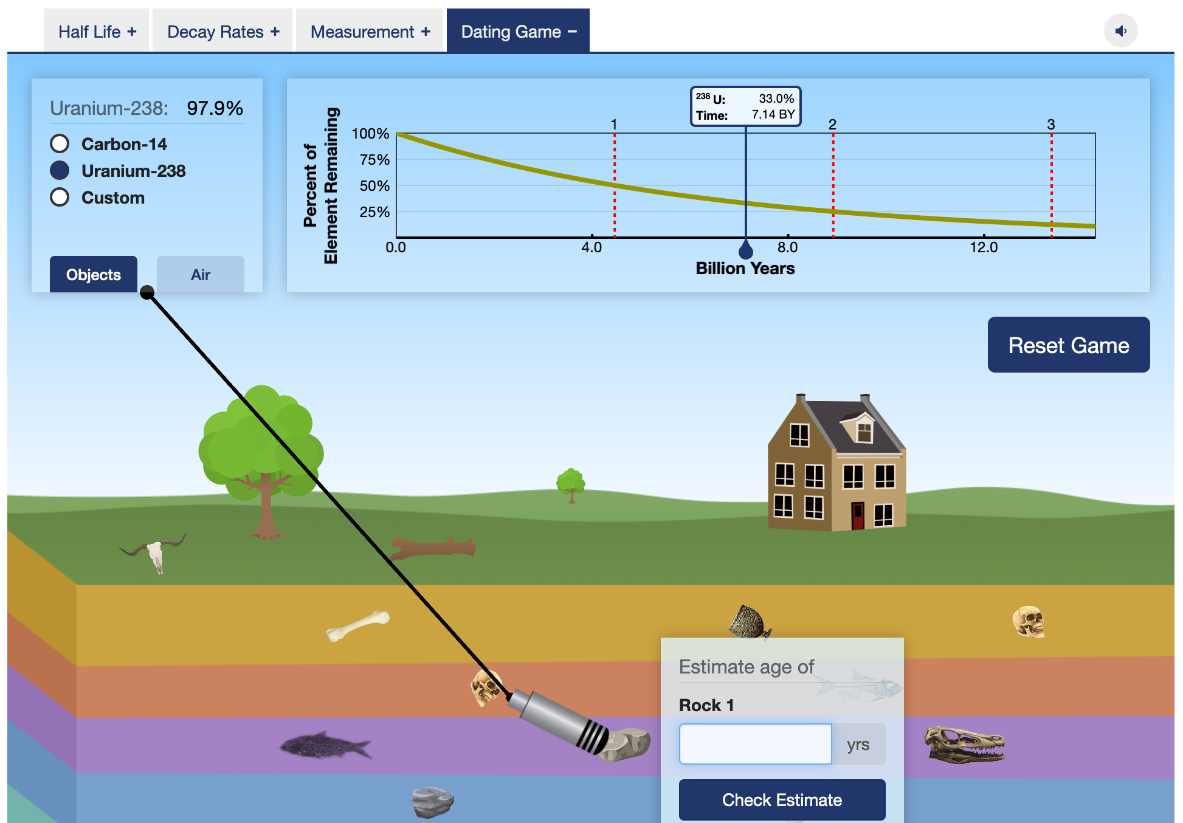

5. The box at the top left corner of the screen should now say something similar to Uranium-238: 97.9%. You are going to drag the blue marker line on the chart to the left until it reads ²³⁸U: 97.9% (you will probably not be able to get right on that percentage -- but get as close as you can):

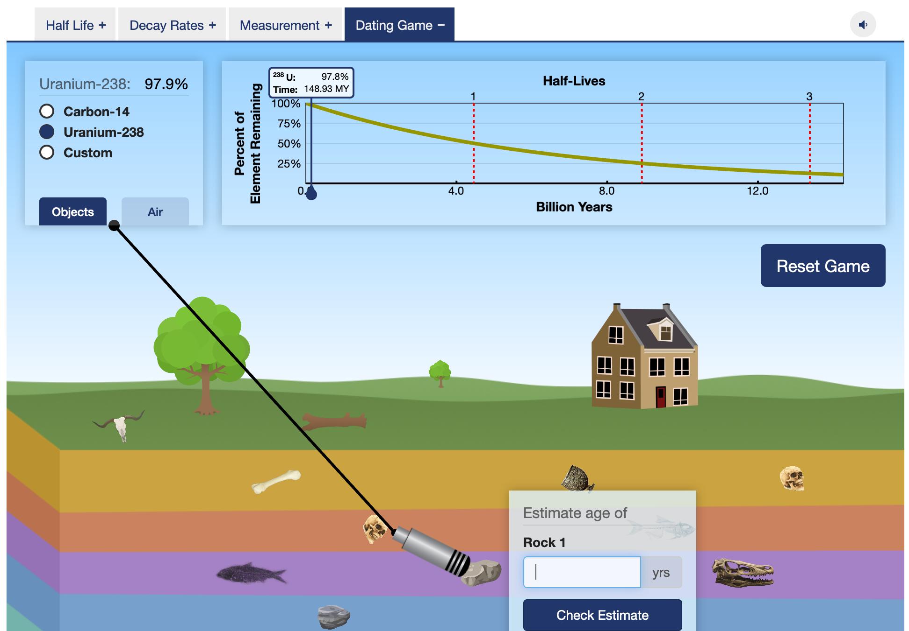

6. See that it gives a time of 148.93 MY (million years). The box for “Rock 1” asks for the age of the rock in Years. That means we have to change 148.93 million years into years: 148,930,000. If you enter this into the box for “Rock 1”, you will see if you are correct:

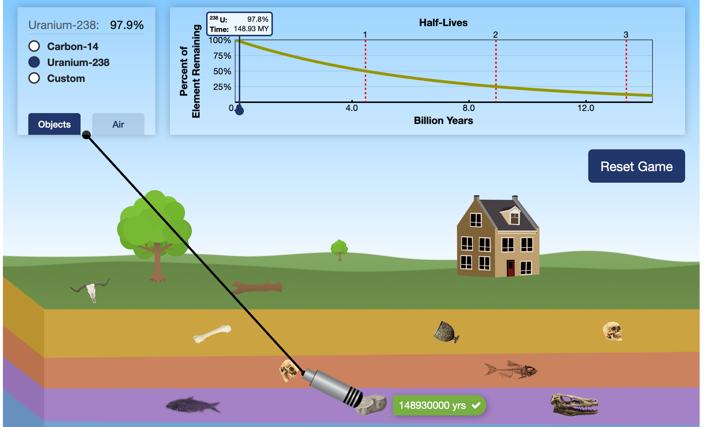

7. Success! This is how you work through finding the ages for the various items on the list. Have fun!

